**TestRail Project Setup Document: BookStore Application**

Test Cases:

1. Bookstore Signup Page

2. BookStore Search Page

3. Bookstore Login Page

**Test Case 1: Bookstore Signup Page**

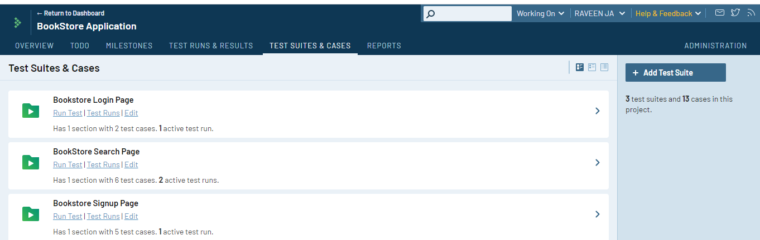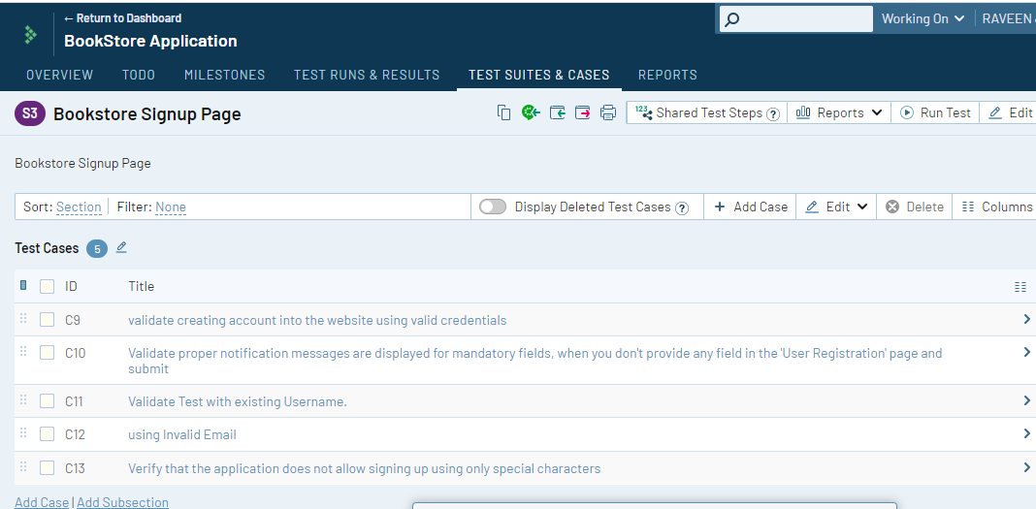

––

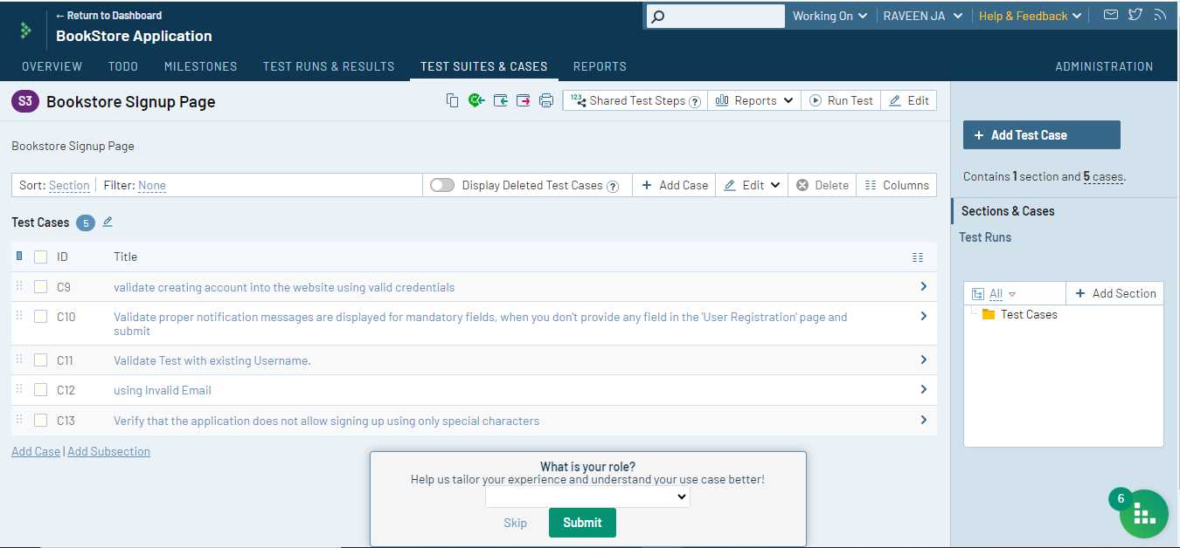

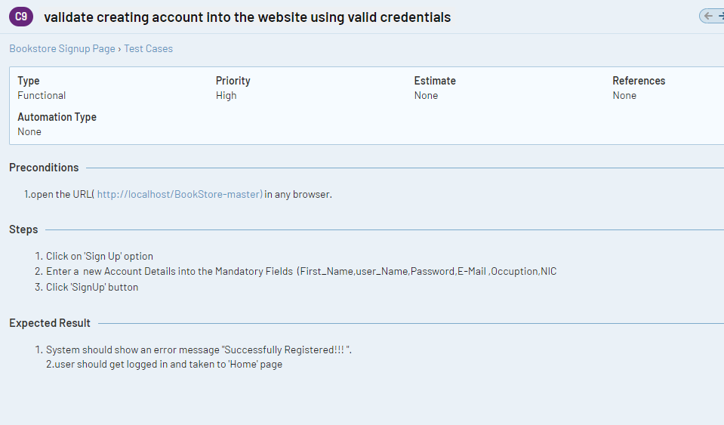

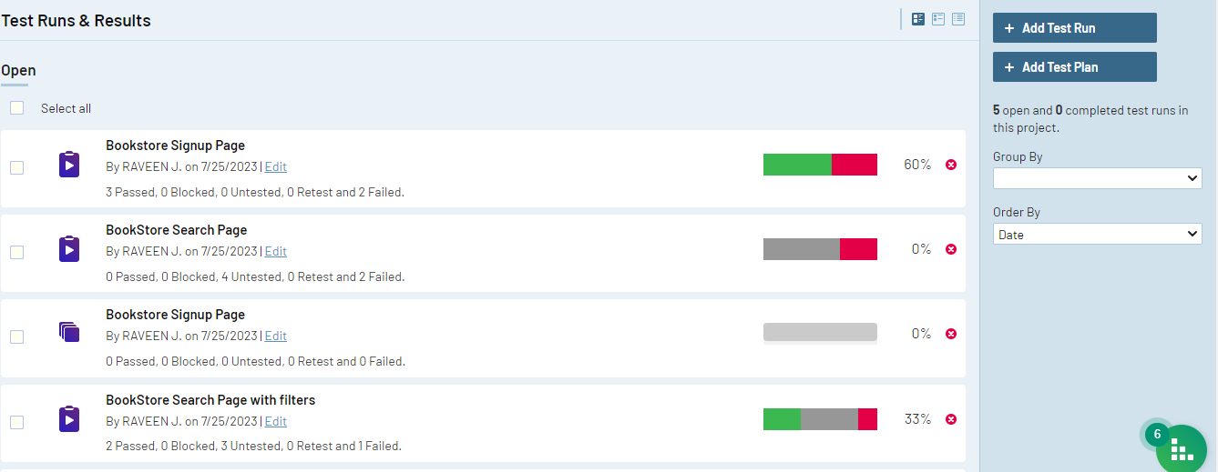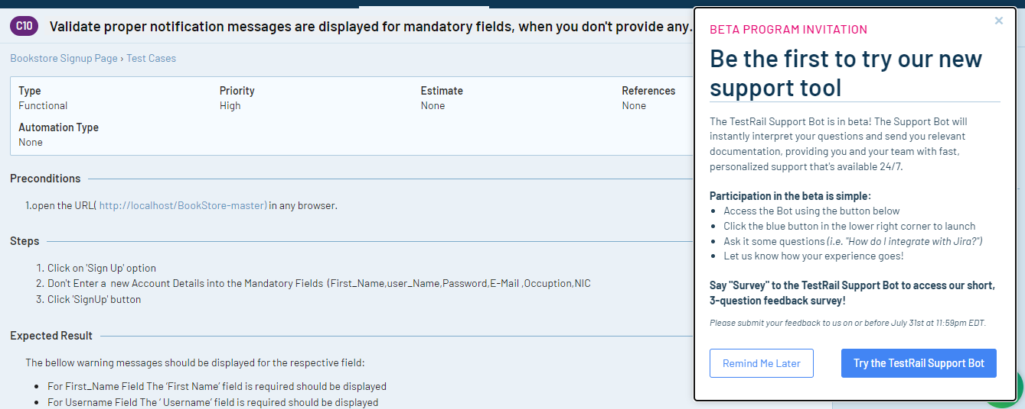

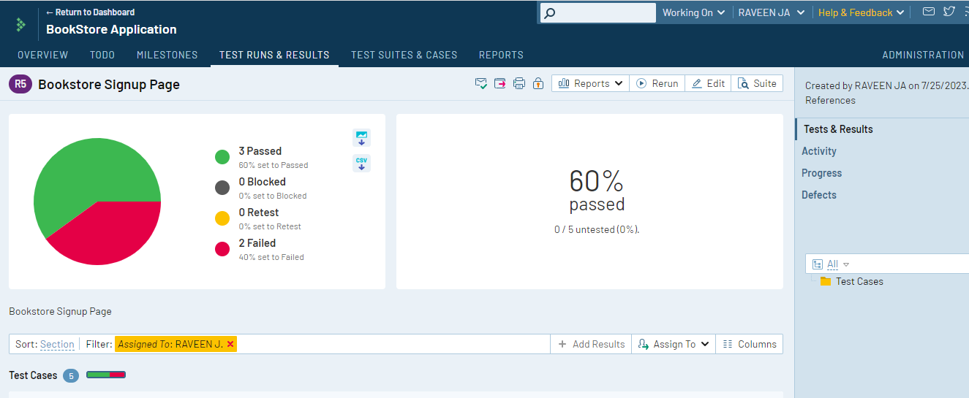

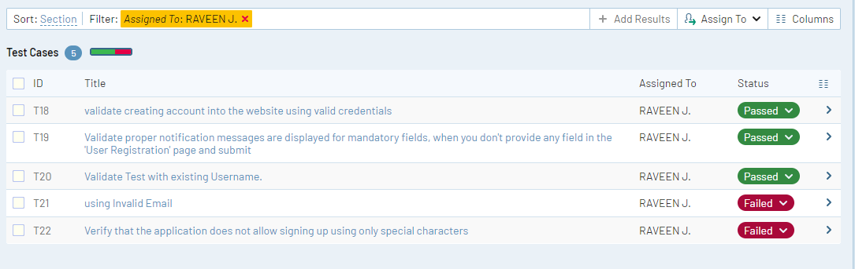

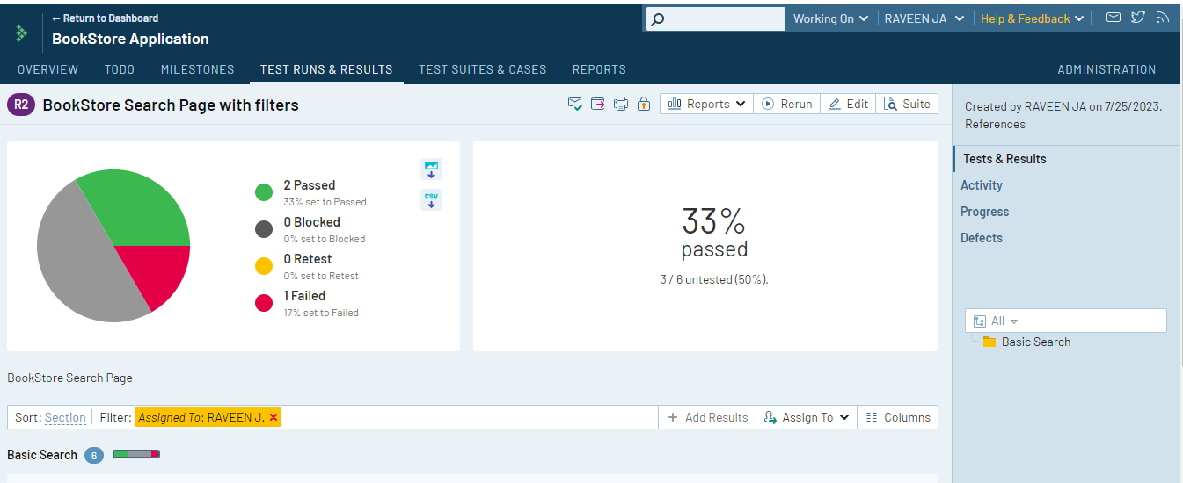**Test Case 2: BookStore Search Page**

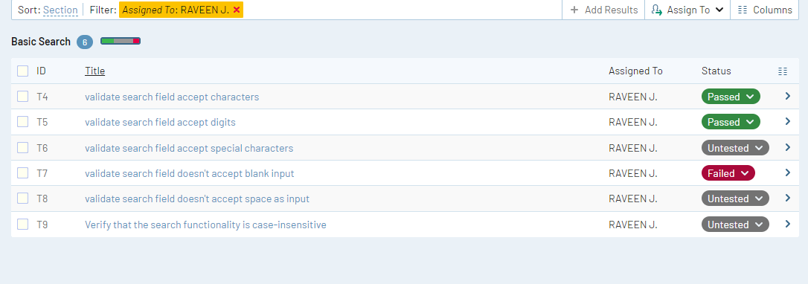

**Test Case 3: Bookstore Login Page**

